2

Title: Eu Development: widening and Depening
Subject: EEP 1

Widening

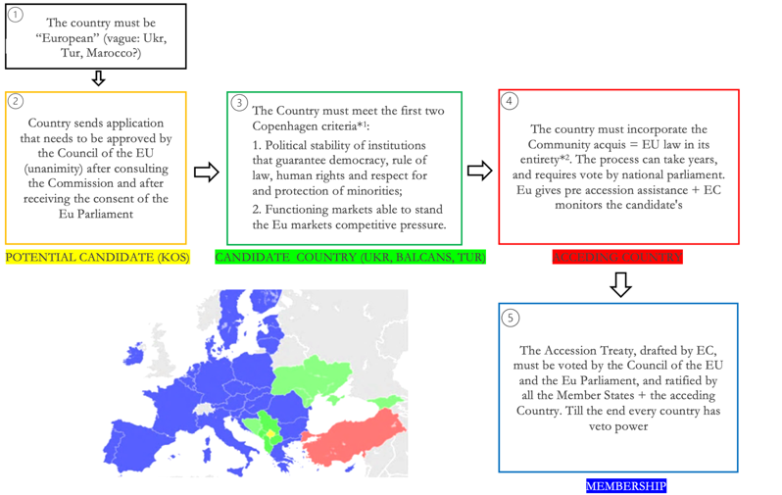
*1June 1993 Copenhagen criteria for accession of Central and Eastern European Countries
*2This is the third “Copenhagen criterion”

1948 OEEC (Marshall Plan): provide aid while embedding Ger into a supranational entity. Success! => further cooperation
After WWII: Eu needed money for reconstruction & to avoid new wars + Us needed a strong block vs USSR. BUT for this strong Ger (worrying).
1951 European Coal and Steel Community (Treaty of Paris): Bel, Fra, Ger, Ita, Net and Lux place their coal/steel under control of a supranat auth. Aim: g through cooperation + control key resources for Ger rearment

xq

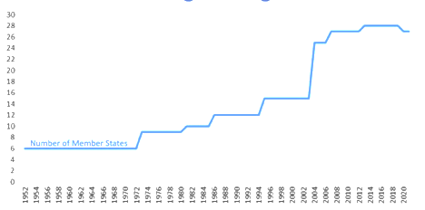
1957 European Economic Community (Treaty of Rome): expand succesfull ECSC: the Six committed to forming CU + Signle market

1989: EEA. Europe divided: EEC6 a custom union and EFTA7 an FTA (Nordic countries + Uk):
i. EEC started g >>> EFTA
ii. Trade discrimination, EFTA cannot enter the attractive EEC mkt => Many EFTA member applied for EEC
iii. The European Economic Area (EEA): 4th enlargement

EC 1991: Maastricht Treaty EEC renamed European Union (EU) to reflect wider economic competences.
After USSR break up the ex-Warsaw pact nations came closer. The 2004 enlargement deeply changed the EU => need to reform Eu institutions. European Council (2006) agreed to consider carefully the EU's capacity to integrate new members in the future. Now: We also have Shengen, Eurozone, Nato and EPC.
*EPC = The European Polical Community: called by Macron after Russia’s invasion to serve as a forum for polical dialogue and cooperation

1

*

Turkiye: applied for membership in 1987 (Potential Candidate), and it was declared eligible in 1997 (Candidate country, in CU from 1995). In 2018 the Council froze negotiations.
Formal reason: refuses to recognize Cyprus and it has not removed all obstacles to the free movement of ppl.
Real Reason: Eu has serious concerns on democratic inst, rule of law+disalignment with Eu (Russia,Hamas)

Ukraine: On 28 February 2022 (4 days after Russia's invasion), Ukraine sent its application for EU membership. Eu granted it candidate status (actually not ready, political decision). End of 2023 Negotiations started.

Deepening(Policy Integration): History of Eu is marked from a progrerssive expansion of Eu competencies.

The exercise of EU competences is defined in:
- Treaty on European Union (TEU): Objectives, and principles
- Treaty on the functioning of the Eu (TFEU): Details

Eu on some issues is Supranational (exclusive competence) on others Intergovernmetnal
(Foreign pol, Defence):

The principle of conferral: the EU may only act within the limits of the competences conferred by countries in the Treaties to attain the objectives provided therein.
Three fundamental principles

The principle of proportionality: EU action may not go beyond what is necessary to achieve the objectives of the Treaties.

The principle of subsidiarity: in the area of its non-exclusive competences, the EU may act only if the objective of a proposed action cannot be sufficiently achieved by the EU countries, but could be better achieved at EU level. Ex. UBER: The EU has responsibility when transport is of transnational nature. Urban transport (eg, regulation of taxis) is in the hands of national and local authorities(Uberpop banned in Italy, but it works in Poland)

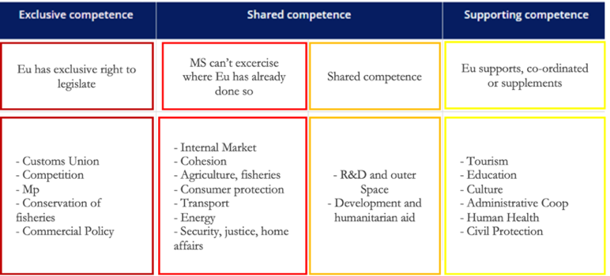

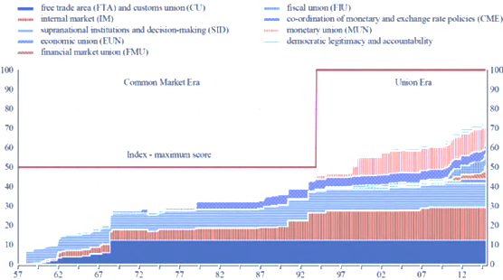
History:
I. FTA and CU (’69 huge improvement bc they set CET)

II. Gradual build-up of the European Internal Market

III. Progressive EMU development. BW fall Alarm bell that created need for common currency --> Economic and Monetary Union EMU (1992)

*GRAPH: Red line: max integration you have on the basis of the treaties

Missing (hamronizaiton in these fields is politically difficult):
Common welfare policy ( health, education, labour market regulation, pensions)

Taxation, apart from VAT general framework (min 15%). BUT, harmonization really necessary? In low-T countries, workers will enjoy a higher net salary, but as low T = Low G => less services

